SKILL + JOB MATCHING SYSTEM
A Web Based Application Major Project Report
Submitted in Partial Fulfillment of the Requirement for the Award of Degree of
BACHELOR OF COMPUTER APPLICATIONS

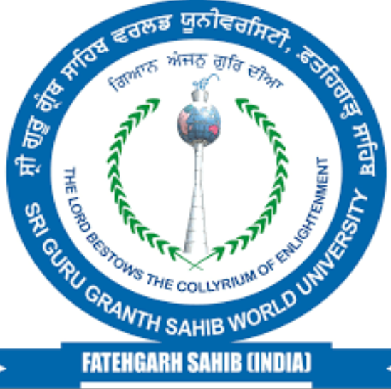

Submitted By: | Under the Guidance of:
Tinku | Ms. Rupinder Kaur
BCA Final Year | Assistant Professor
Roll No: 2023CSCU408 | Department of Computer Science

DEPARTMENT OF COMPUTER SCIENCE
SRI GURU GRANTH SAHIB WORLD UNIVERSITY
FATEHGARH SAHIB, PUNJAB
Academic Session: 2023–2026
Submitted in: April 2026
CERTIFICATE

This is to certify that the Major Project Report entitled “SKILL + JOB MATCHING SYSTEM” submitted by Mr. Tinku, Roll No. 2023CSCU408, in partial fulfillment for the award of the degree of Bachelor of Computer Applications (BCA) to Sri Guru Granth Sahib World University, Fatehgarh Sahib, is a bona fide record of the work carried out by him under my supervision and guidance during the academic session 2023–2026. at Sri Guru Granth Sahib World University.
To the best of my knowledge, this work has not been submitted elsewhere for the award of any other degree, diploma or certificate.
The project work is found satisfactory and approved for submission.

Date: ____________ Ms. Rupinder Kaur
Place: Fatehgarh Sahib Assistant Professor
(Project Guide)

Head of Department
Department of Computer Science

